PROM8908F Advanced Gang Programmer
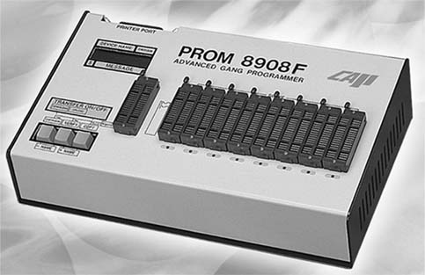
Extended :
It supports 8bit EPROM/FLASH from 64K to 64M, 16bit EPROM memory from 1M to 16M, Atmel AT90S1200, AT89C1051/2051 and more...
Fast :
It takes 5.3 seconds to check/write/verify eight 27256 devices without sacrificing the high yield at the same time.
Reliable :
All the slave sockets are completely isolated except the power pin. This gives a guarantee for minimum loss caused by defected device.
Main features:
Completely stand alone operation with helps from a 16x2 characters LCD display, an audible buzzer and eight go/no-go LED lamps.
One master and eight slaves 40pin ZIF sockets. It can support the 32pin DIP package directly up to 8Mega, and can be expanded to 64Mega with proper adaptors.
Eight standard commands: Checksum, Verify, Copy, +Name, -Name, Algorithm, Force and Upload/Download. Special device has extra command applied such as the sector-protection settings.
Transfer files to/from PC via the standard parallel port(LPT1,LPT2,LPT3).
On-field calibration and verify-voltage-selection feature.
Basic specification:
Dimension: 33.5cm x 20cm x 8cm.
Weight: 3.0Kg.
Material: Heavy-duty Aluminum.
Operating enviroment: 95V to 240V, 50/60Hz.
Life time free software updates via WWW.
Free technical support and 1 year warranty.

